Class: AWS Administration
Project: Cloud Security Builder Version: 1.0 (Initial Release)
Author: AWS
Project Environment: AWS Academy Cloud Security Builder
Synopsis
This project is completed in the AWS Academy. It’s completely contained in a standalone class:
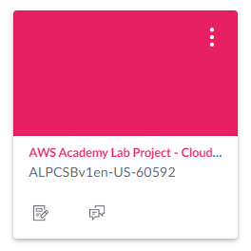
How to Proceed
You’ll need to complete all sections in the project as shown below:
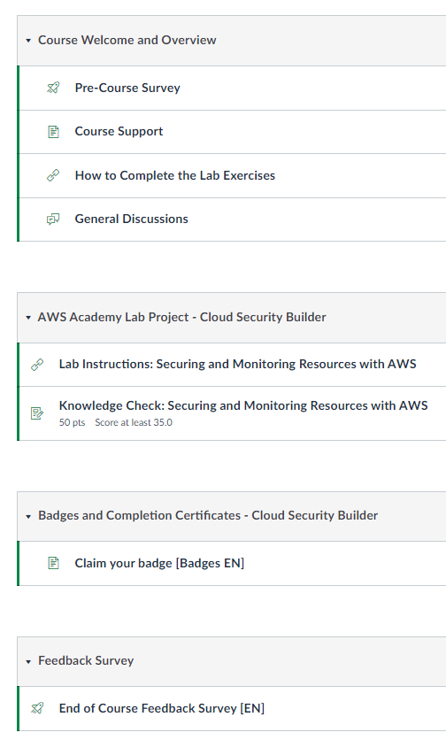
Scoring Breakdown:
Phase 1 Screenshots: 20pts
Phase 2 Screenshots: 20pts
Phase 3 Screenshots: 20pts
Phase 4 Screenshots: 20pts
Knowledge Check: 20pts
Total: 100pts

Phase 1: Security Data in Amazon S3
Note about building a test S3 bucket first:
All - in the first part of the Cloud Security Builder Project if you configure your bucket policies wrong on the data-bucket you are building you can EASILY lock yourself out of your bucket. I can't fix it for you. You would need to "reset" your lab environment to start over.
My suggestion: create a test bucket and craft your bucket policies per the instructions from the lab on that one FIRST. Test it, copy the bucket policies out if all is good and then delete that bucket (if you can't delete it your policies are still incorrect).
Two common issues come up as folks start on the lab: accidentally switching the allow vs deny and not enabling ALL S3 actions.

Task 1.1
- When creating the bucket policy we normally would use the bucket policy generator but Amazon has apparently killed that (for now) – don’t attempt to manually write the bucket policy. Instead use CoPilot or ChatGPT to generate the policy for you....type all the requirements for the two rules as outlined in the directions and either AI model will give you back a bucket policy that you can plug in with minor modification – you'll need to substitute YOUR account number in the ARNs, your actual bucket name, etc. You can find your account number in the upper right corner of the screen when logged into the AWS console.

- The instructions ask you to add the voclabs role ARN to the Conditions. If you go to the role section in IAM and attempt to look at the ARN for that role you won’t have permission to see it. It looks just like a user ARN but is prefaced with role rather than user. Look at one of your users ARNs in the policy you are creating and just swap user for role and voclabs as the name. Example:
arn:aws:iam::acctnumber:role/voclabs

Example: arn:aws:iam::627668249898:role/voclabs

- You will need to list your bucket ARN twice in the Policy generator. Once with just the name of the bucket in the ARN and once with /* appended to the end separated by a comma. It would like this (note that your unique code for your data-bucket will be different:
arn:aws:s3:::data-bucket-096c40d9eee7bb9dc,arn:aws:s3:::data-bucket-096c40d9eee7bb9dc/*
The difference between the two is that your bucket ARN with the /* appended to the end of it is a wildcard referring to ALL the objects in the bucket. Otherwise, your users specified in the Conditions section would be able to affect bucket options but not actually access things IN the bucket.
Task 1.2
- No changes or notes. You’ll want to test that versioning and object-level logging are working but you’ll do that in the final steps.
Task 1.3
- No changes or notes.
Task 1.4
- Note that user Paulo SHOULD be able to see and open files in the data bucket but user Mary will NOT be able to. Recall that the user’s passwords are in the details are of the lab interface for this lab – you can obtain their sign-in links from their IAM accounts under “Security Credentials”.
Task 1.5
- It may take SOME TIME for the first access logs to arrive in the objects-access-logs S3 bucket. You must have performed the previous steps with those two users so there is access to actually log as well – if you skipped those steps – go back and do them now. It might take 30+ minutes.
- BEFORE opening Athena, obtain the unique ID number at the end of the s3-objects-access-log-xxxxxxxxx bucket as you will need it for the Athena data query.
- When pasting the query into the Query 1 editor in Athena DO NOT copy and paste the xxxxxxxxxx line as shown in the lab directions:
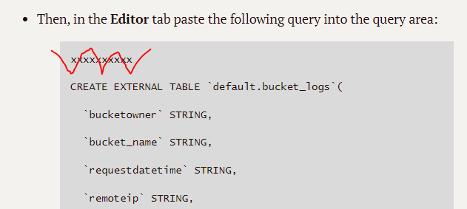
- After running that first query in Athena – to preview the bucket logs table data:
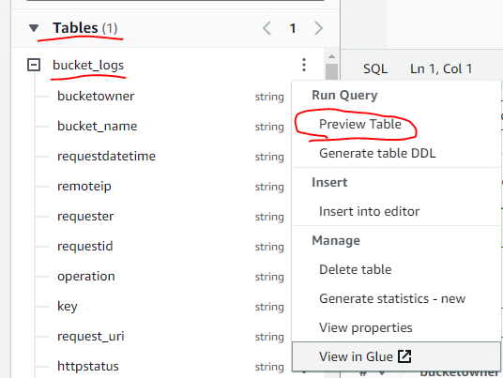
- After running the 2nd query of the bucket_logs table in Athena that filters out the voclabs user and just shows paulo and mary take a screenshot of some of the returned data that shows paulo and mary logged attempts.
Cost Assessment Question – Looking at the cost implications for S3 question at the end of Phase 1 consult the links for the Amazon S3 Pricing and Athena Pricing and write a small statement on what the customer will be paying for to use these services based on how you have them configured below:

Phase 1 Screenshots & Questions
Screenshot #1 – Screenshot of your list of S3 buckets at the end of Phase #1.
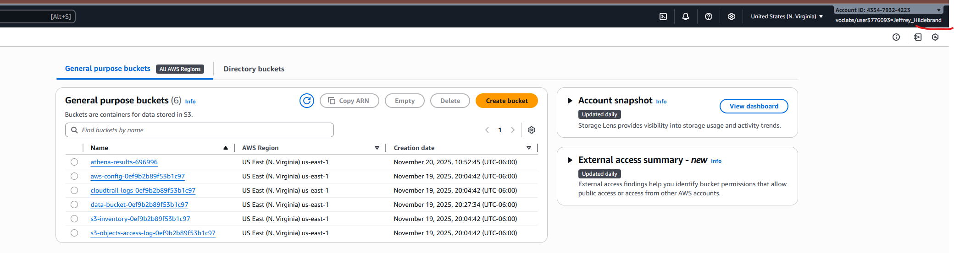
Screenshot #2 – Screenshot of the versions tab of your customers.csv file in the data-bucket – should show AT LEAST two versions you uploaded
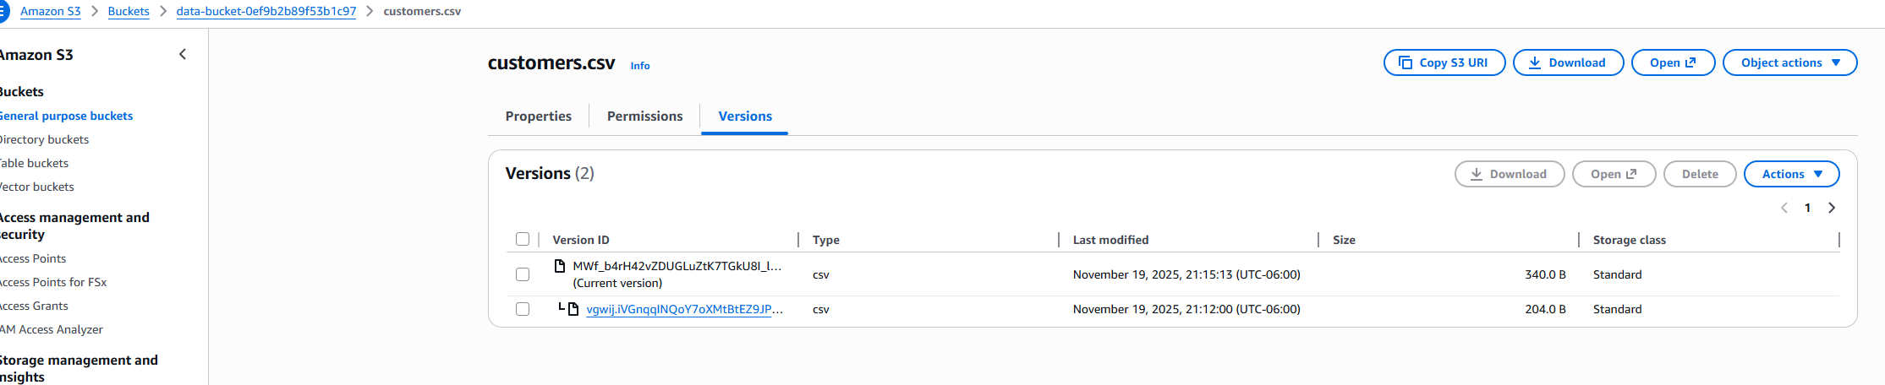
Screenshot #3 – Screenshot of some of the results of the 2nd query where the original query has the data filtered to just show paulo and mary data. The entire log is too long for one screenshot so a screenshot of just a few lines of the log are fine. This is the query you ran to refine the results:
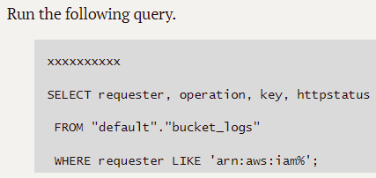
Here is an example from my logs:
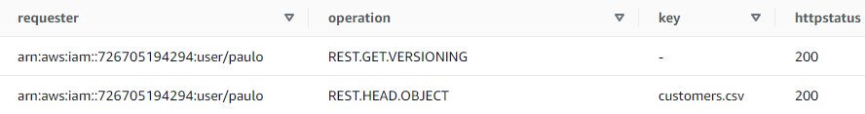

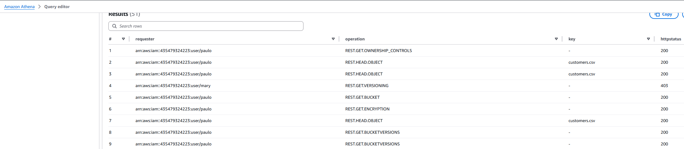

Phase 2: Securing VPCs

Task 2.2
- The IAM role you need to use is: VPCFlowLogsRole
Task 2.3
- netcat (nc) will probably need to be installed on your Cloud 9 IDE (sudo yum install netcat).
Task 2.6 through 2.10
- Note this warning for the final tasks of Phase #2 – MAKE SURE YOU HAVE COMPLETED THE QUESTIONS BELOW BEFORE TAKING DOWN THE FIREWALL HOWEVER:

Make sure you do steps 2.6 through 2.10 when you can do it in ONE session ideally and make sure you delete the firewall components as instructed when you are done after answering the questions below...

Phase 2 Screenshots & Questions
Screenshot #1 – Screenshot of the final configuration of the security group attached to the webserver showing the 3 rules.
<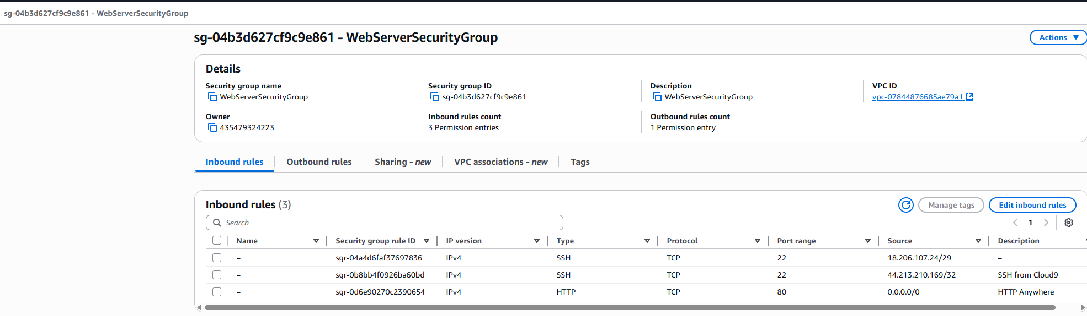
Screenshot #2 – Screenshot of the VPC Flow Log showing a successful port 22 and port 80 request coming from your Cloud 9 IDE instance using netcat to the webserver (NOT webserver2). This is covered in Task 2.3
<INSERT SCREENSHOT HERE>
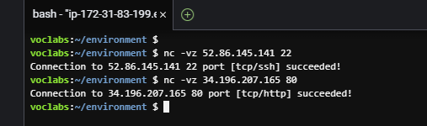

Question #3 – Complete the missing pieces of the network configuration diagram after completing task 2.8 (make sure to do this before you do any of the clean up activities at the end of 2.10 or you’ll have to do it again). Download the PowerPoint graphic at the link below fill it in and include it with your project submission.
Download the diagram here: https://aws-tc-largeobjects.s3.us-west-2.amazonaws.com/CUR-TF-200-ACCAP6-91948/capstone-6-security/s3/phase2-diagramming-activity.pptx
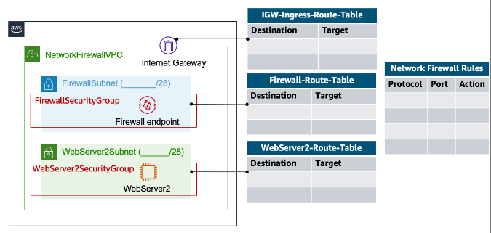
TCP 8080 DROP
TCP 80 DROP
TCP 22 PASS
TCP 443 PASS
ICMP ALL PASS
10.1.3.0/28 Firewall Endpoint
10.1.1.0
0.0.0.0/0 igw-007bff0c5df43884d
10.1.0.0/16 LOCAL
0.0.0.0/0 Firewall Endpoint
10.1.3.0/28
10.1.0.0/16 Local

10.1.0.0/16 Local

Screenshot #4 – Screenshot of the final configuration of the NetworkFirewallVPCRuleGroup with all of your rules built (Task 2.10 Step #2)
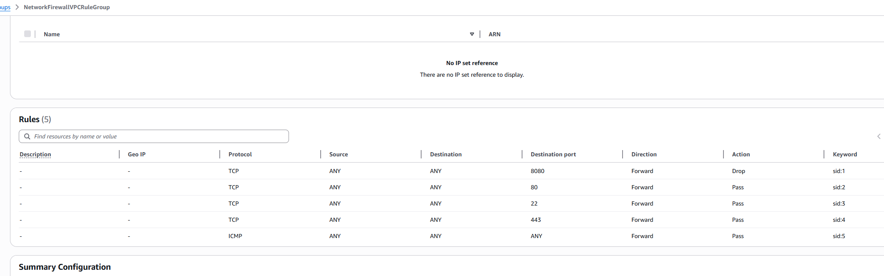

Phase 3: Securing AWS resources by using AWS KMS
Phase 3 Screenshots & Questions
Screenshot #1 – Screenshot of the error message user Paulo receives when they attempt to access the loan-data.csv file in S3 (Task 3.3 Step #6):

Screenshot #2 – Screenshot of the value of mysecret when retrieved with aws secretsmanager get-secret-value … (Task 3.6 Step #2):
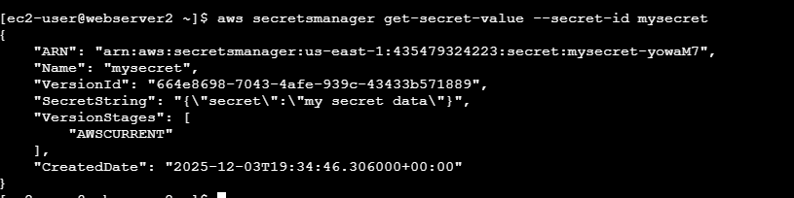

Phase 4: Monitoring and Logging
Task 4.1 (Step #4)
- Setting up the Athena table can be challenging. Their link to the Cloud Trail documentation will help. Here is where to locate the preview button for your exported log in Athena:
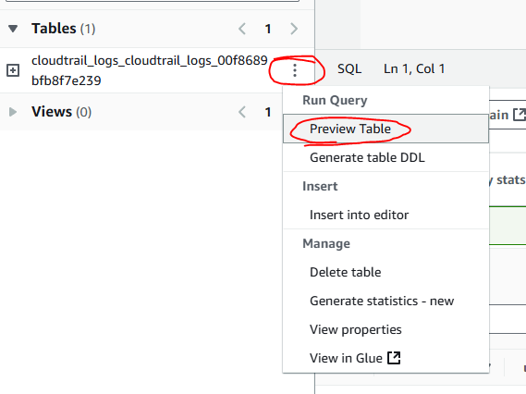
- Ignore the Step #6 Challenge exercise for Athena unless you are really interested in it.

Phase 4 Screenshots & Questions
Screenshot #1 – Screenshot of the email you received from the Cloud Watch alarm indicating you’d received your threshold amount of invalid SSH attempts (Task 4.3 Step #6):
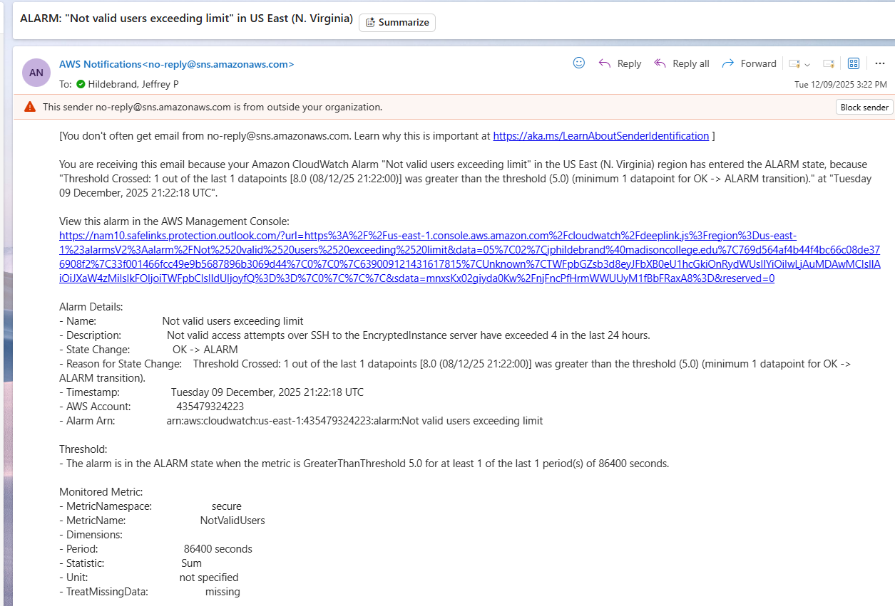
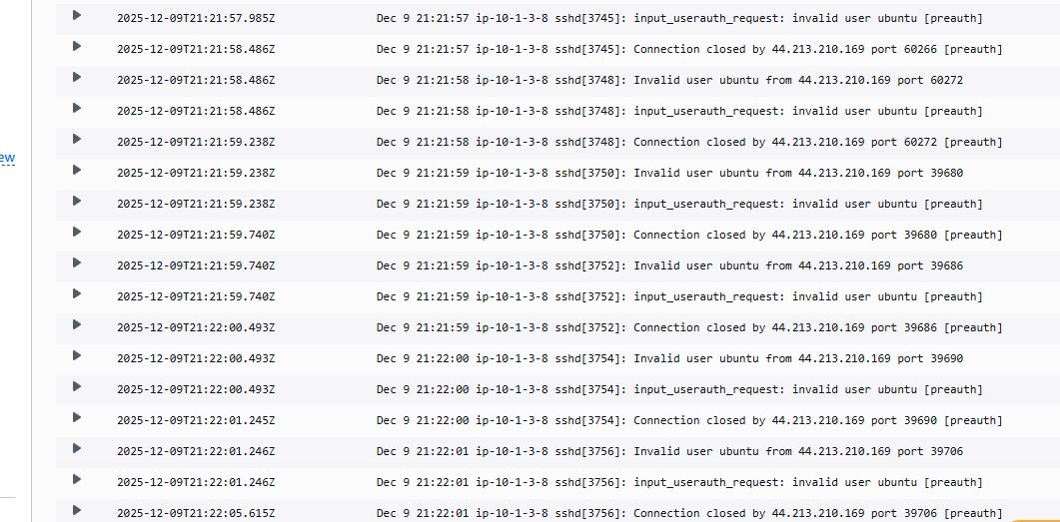Screenshot #2 – Screenshot of the “Resources in Scope” section of the s3-bucket-logging-enabled rule showing that your remediation action has executed successfully. (Task 4.4 Step #8):
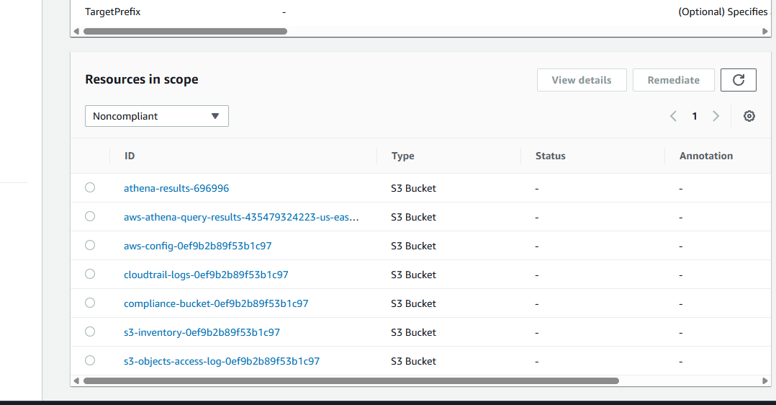Question #3 – After you perform the manual remediation check the S3 bucket “compliance-bucket” to see if your manual remediation actually worked and bucket logging is now enabled – I found this to be problematic in the lab and it may or may not work for you:

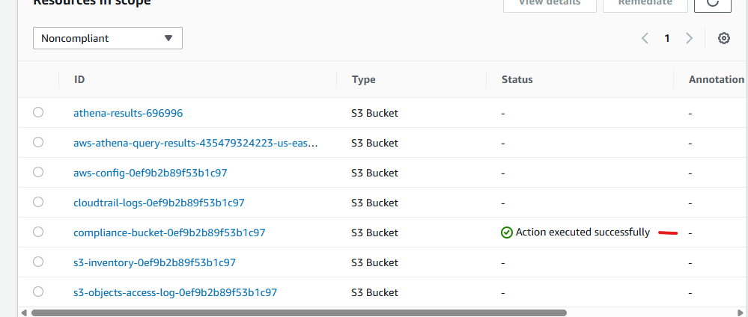
Is bucket logging enabled on your bucket after the manual remediation?
yes

Post Project Completion: Knowledge Check: Securing and Monitoring Resources with AWS

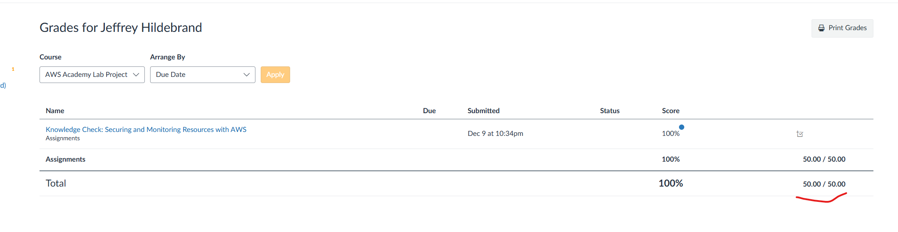
** Make sure to also claim your digital badge from the project website on the AWS Academy if you like and track badges **

